**Conditions**

Following  methods are used  in conditional and looping operations --

* **isEnabled()** is used when you want to verify whether a certain element is enabled or not before executing a command.

[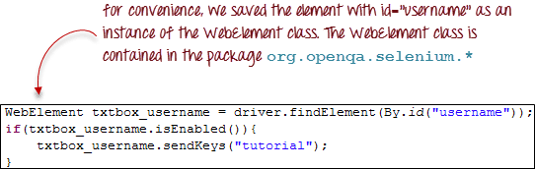](http://cdn.guru99.com/images/image043(1).png)

* **isDisplayed()** is used when you want to verify whether a certain element is displayed or not before executing a command.

[First Selenium Webdriver Script: JAVA Code Example](http://cdn.guru99.com/images/image044(1).png)

* **isSelected()** is used when you want to verify whether a certain **check box, radio button, or option in a drop-down box** is selected. It does not work on other elements.

[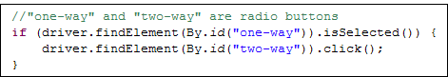](http://cdn.guru99.com/images/image045.png)

**Using ExpectedConditions**

The ExpectedConditions class offers a wider set of conditions that you can use in conjunction with WebDriverWait's until() method.

Below are some of the most common ExpectedConditions methods.

* **alertIsPresent()**- waits until an alert box is displayed.

[First Selenium Webdriver Script: JAVA Code Example](http://cdn.guru99.com/images/image046(1).png)

* **elementToBeClickable()** - Waits until an element is visible and, at the same time, enabled. The sample code below will wait until the element with id="username" to become visible and enabled first before assigning that element as a WebElement variable named "txtUserName".

[First Selenium Webdriver Script: JAVA Code Example](http://cdn.guru99.com/images/image047(1).png)

* **frameToBeAvailableAndSwitchToIt()**- Waits until the given frame is already available, and then automatically switches to it.

[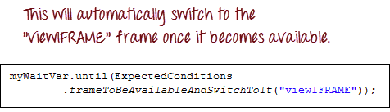](http://cdn.guru99.com/images/image048(1).png)

**Catching Exceptions**

When using isEnabled(), isDisplayed(), and isSelected(), WebDriver assumes that the element already exists on the page. Otherwise, it will throw a **NoSuchElementException**. To avoid this, we should use a try-catch block so that the program will not be interrupted.

WebElement txtbox_username = driver.findElement(By.id("username"));

try{

if(txtbox_username.isEnabled()){

txtbox_username.sendKeys("tutorial");

}

}

catch(NoSuchElementException nsee){

System.out.println(nsee.toString());

}

If you use explicit waits, the type of exception that you should catch is the "TimeoutException".

[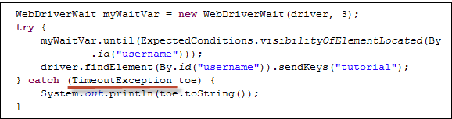](http://cdn.guru99.com/images/image050(2).png)